RISK MANAGEMENT
Risk is an undesired event or circumstance that occur while a project is underway
- It is necessary for the project manager to anticipate and identify different risks that a project may be susceptible to.
Risk Management aims at reducing the impact of all kinds of risk that may affect a project by identifying, analyzing and managing them
Reactive vs Proactive Risk Strategies
Reactive Risks: project team reacts to risks when they occur. The team flies into action in an attempt to correct the problem rapidly. This is often called a fire fighting mode. When this fails, “crisis management” takes over and the project is in real jeopardy.
Proactive Risks
Potential risks are identified, their probability and impact are assessed, and they are ranked by importance.
The software team establishes a plan for managing risk. The primary objective is to avoid risk, but because not all risks can be avoided, the team works to develop a contingency plan that will enable it to respond in a controlled and effective manner.
Software Risks
Risk always involves two characteristics
Uncertainty the risk may or may not happen;
Loss if the risk becomes a reality, unwanted consequences or losses will occur.
When risks are analyzed, it is important to quantify the level of uncertainty and the degree of loss associated with each risk
The type of risks that we likely encounter as software is built?
- Project risk: Threaten the project plan and affect schedule and resultant cost
- Technical risk: Threaten the quality and timeliness of software to be produced
- Business risk: Threaten the viability of software to be built
- Known risk: These risks can be recovered from careful evaluation
- Predictable risk: Risks are identified by past project experience
- Unpredictable risk: Risks that occur and may be difficult to identify

Risk Identification
Risk identification is a systematic attempt to specify threats to the project plan (estimates, schedule, resource loading, etc.). By identifying known and predictable risks,the project manager takes a first step toward avoiding them when possible and controlling them when necessary.
Two distinct types of risks for each category of risks specified above
Generic risks are a potential threat to every software project.
Product-specific risks can be identified only by those with a clear understanding of the technology, the people, and the environment that is specific to the project at hand.
One method for identifying risks is to create a risk item checklist. The checklist can be used for risk identification
Product size risks associated with the overall size of the software to be built or modified.
Business impact risks associated with constraints imposed by management or the marketplace.
Customer characteristics risks associated with the sophistication of the customer and the developer's ability to communicate with the customer in a timely manner.
Process definition risks associated with the degree to which the software process has been defined
Development environment risks associated with the availability and quality of the tools to be used to build the product.
Technology to be built risks associated with the complexity of the system to be built and the "newness" of the technology that is packaged by the system.
Staff size and experience risks associated with the overall technical and project experience of the software engineers who will do the work.
Assessing Project Risk
- Have top software and customer managers formally committed to support the project?
- Are end-users enthusiastically committed to the project and the system/product to be built?
- Are requirements fully understood by the software engineering team and their customers?
- Have customers been involved fully in the definition of requirements?
- Do end-users have realistic expectations?
- Is project scope stable?
- Does the software engineering team have the right mix of skills?
- Are project requirements stable?
- Does the project team have experience with the technology to be implemented?
- Is the number of people on the project team adequate to do the job?
- Do all customer/user constituencies agree on the importance of the project and on the requirements for the system/product to be built?
Risk Components and Drivers
The risk components are defined in the following manner.
- Performance risk—the degree of uncertainty that the product will meet its requirements and be fit for its intended use.
- Cost risk—the degree of uncertainty that the project budget will be maintained.
- Support risk—the degree of uncertainty that the resultant software will be easy to correct, adapt, and enhance.
- Schedule risk—the degree of uncertainty that the project schedule will be maintained and that the product will be delivered on time.
The impact of each risk driver on the risk component is divided into one of four impact categories—negligible, marginal, critical, or catastrophic.
Risk Projection
It estimates the impact of risk on the project and the product
Risk projection, also called risk estimation, attempts to rate each risk in two ways
  - the likelihood or probability that the risk is real
  - the consequences of the problems associated with the risk, should it occur.
The project planner, along with other managers and technical staff, performs four risk projection activities
- establish a scale that reflects the perceived likelihood of a risk
- delineate the consequences of the risk
- estimate the impact of the risk on the project and the product, note the overall accuracy of the risk projection so that there will be no misunderstandings

Developing a Risk Table
A risk table provides a project manager with a simple technique for risk projection
Impact values
Catastrophic-1 Critical-2 Marginal-3 Negligible-4
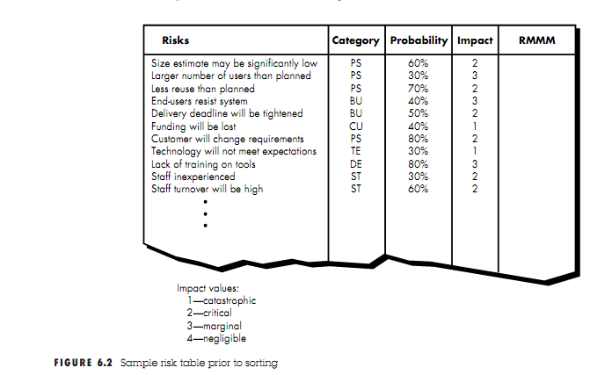
A project team begins by listing all risks This can be accomplished with the help of the risk item checklists Each risk is categorized in the second column (e.g.,PS implies a project size risk, BU implies a business risk) The probability of occurrence of each risk is entered in the next column of the table. The probability value for each risk can be estimated by team members individually. Next, the impact of each risk is assessed.
Once the first four columns of the risk table have been completed, the table is sorted by probability and by impact. High-probability, high-impact risks percolate to the top of the table, and low-probability risks drop to the bottom. This accomplishes first-order risk prioritization.
The project manager studies the resultant sorted table and defines a cutoff line. The cutoff line (drawn horizontally at some point in the table) implies that only risks that lie above the line will be given further attention. Risks that fall below the line are re-evaluated to accomplish second-order prioritization.
Referring to Figure 6.3, risk impact and probability have a distinct influence on management concern. A risk factor that has a high impact but a very low probability of occurrence should not absorb a signiﬁcant amount of management time. However, high-impact risks with moderate to high probability and low-impact risks with high probability should be carried forward into the risk analysis steps that follow.
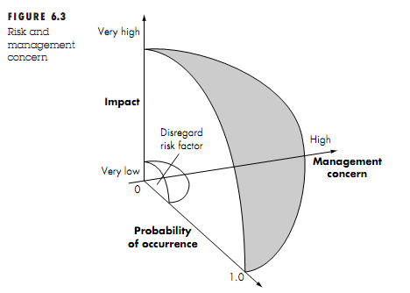
The column labeled RMMM contains a pointer into a Risk Mitigation, Monitoring and Management Plan or alternatively, a collection of risk information sheets developed for all risks that lie above the cutoff.
Assessing Risk Impact
The overall risk exposure, RE, is determined using the following relationship
RE = P x C
Where
P is the probability of occurrence for a risk, and
C is the cost to the project should the risk occur
For example, assume that the software team deﬁnes a project risk in the following manner:
Risk identiﬁcation. Only 70 percent of the software components scheduled for reuse will, in fact, be integrated into the application. The remaining functionality will have to be custom developed.
Risk probability. 80% (likely).
Risk impact. 60 reusable software components were planned. If only 70 percent can be used, 18 components would have to be developed from scratch (in addition to other custom software that has been scheduled for development). Since the average component is 100 LOC and local data indicate that the software engineering cost for each LOC is $14.00,
the overall cost (impact) to develop the components would be 18 x 100 x 14 = $25,200.
Risk exposure. RE = 0.80 x 25,200 ~=$20,200.
Risk Refinement
One way to do this is to represent the risk in condition-transition-consequence (CTC).
Using the CTC format for the reuse risk we can write:
Given that all reusable software components must conform to specific design standards and that some do not conform, then there is concern that (possibly) only 70 percent of the planned reusable modules may actually be integrated into the as-built system, resulting in the need to custom engineer the remaining 30 percent of components.
This general condition can be reﬁned in the following manner:
Subcondition 1. Certain reusable components were developed by a third party with no knowledge of internal design standards.
Subcondition 2. The design standard for component interfaces has not been solidiﬁed and may not conform to certain existing reusable components.
Subcondition 3. Certain reusable components have been implemented in a language that is not supported on the target environment.
Risk Mitigation Monitoring and Management
Its goal is to assist project team in developing a strategy for dealing with risk
If a software team adopts a proactive approach to risk, avoidance is always the best strategy. This is achieved by developing a plan for risk mitigation. For example, assume that high staff turnover is noted as a project risk, r1. Based on past history and management intuition, the likelihood, l1, of high turnover is estimated to be 0.70 percent,and the impact, x1, is projected at level 2.
To mitigate this risk, project management must develop a strategy for reducing turnover. Among the possible steps to be taken are
• Meet with current staff to determine causes for turnover (e.g., poor working conditions, low pay, competitive job market).
• Mitigate those causes that are under our control before the project starts.
• Once the project commences, assume turnover will occur and develop techniques to ensure continuity when people leave.
• Organize project teams so that information about each development activity is widely dispersed.
• Deﬁne documentation standards and establish mechanisms to be sure that documents are developed in a timely manner.
• Conduct peer reviews of all work (so that more than one person is "up to speed”).
• Assign a backup staff member for every critical technologist.
As the project proceeds, risk monitoring activities commence
In the case of high staff turnover, the following factors can be monitored:
• General attitude of team members based on project pressures.
• The degree to which the team has jelled.
• Interpersonal relationships among team members.
• Potential problems with compensation and beneﬁts.
• The availability of jobs within the company and outside it.
In addition to monitoring these factors, the project manager should monitor the effectiveness of risk mitigation steps. For example, a risk mitigation step noted here called
Risk management and contingency planning assumes that mitigation efforts have failed and that the risk has become a reality. Continuing the example, the project is well underway and a number of people announce that they will be leaving. If the mitigation strategy has been followed, backup is available, information is documented,and knowledge has been dispersed across the team.
In addition, the project manager may temporarily refocus resources (and readjust the project schedule) to those functions that are fully staffed, enabling newcomers who must be added to the team to “get up to speed.” Those individuals who are leaving are asked to stop all work and spend their last weeks in “knowledge transfer mode.”
It is important to note that RMMM steps incur additional project cost. For example, spending the time to "backup" every critical technologist costs money.
There are three issues of RMMM
- Actions to be taken in the event that mitigation steps have failed and the risk has become a live problem
- Devise RMMP(Risk Mitigation Monitoring And Management Plan)
RMMM PLAN
1)Risk Avoidance(mitigation) Proactive planning for risk avoidance. This is achieved by developing a plan for risk mitigation.
2)Risk Monitoring what factors can we track that will enable us to determine if the risk is becoming more or less likely?
- Assessing whether predicted risk occur or not
- Ensuring risk aversion steps are being properly applied
- Collection of information for future risk analysis
- Determine which risks caused which problems
3)Risk Management what contingency plans do we have if the risk becomes a reality?
- Contingency planning
A risk management strategy can be included in the software project plan or the risk management steps can be organized into a separate Risk Mitigation, Monitoring and Management Plan. The RMMM plan documents all work performed as part of risk
Each risk is documented individually by using a Risk Information Sheet.
RIS is maintained using a database system
Once RMMM has been documented and the project has begun, risk mitigation and monitoring steps commence.
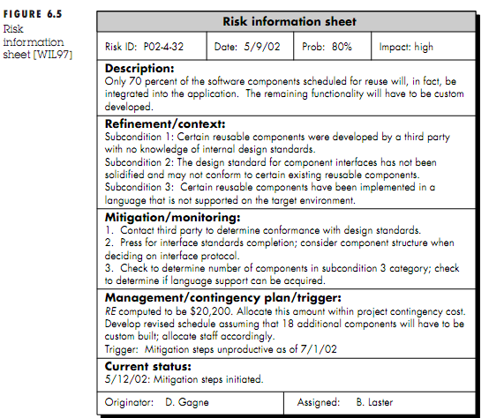

Metrics for Process and Projects
Process metrics are collected across all projects and over long periods of time. Their aim is to provide set of process indicators that lead to long term software process improvement
Project Metrics enable a software project manager to
- Assess status of an ongoing project
- Track potential risks
- Uncover problem areas before they go critical
- Adjust workflow
- Evaluate project teams ability to control quality
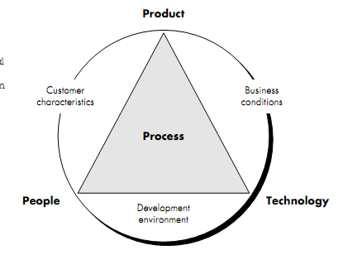
Software Measurement
Software measurement can be categorized as
Direct Measurement
- Direct measure of software process include cost and effort
- Direct measure of product includes lines of code, Execution speed, memory size, defects per reporting time.
Indirect Measurement
- Indirect measure examines the quality of software product itself(e.g. :-functionality, complexity, efficiency, reliability and maintainability)
Reasons for measurement
- To gain baseline for comparison with future assessment
- To determine status with respect to plan
- To predict the size, cost and duration estimate
- To improve the product quality and process improvement
The metrics in software Measurement are
- Size oriented metrics
- Function oriented metrics
- Object oriented metrics
- Web based application metric
Size oriented metrics
- It totally concerned with the measurement of software.
- A software company maintains a simple record for calculating the size of the software.
It includes
- errors per KLOC (thousand lines of code)
- defects per KLOC
- $ per LOC
- pages of documentation per KLOC
- errors per person-month
- Errors per review hour
- LOC per person-month
- $ per page of documentation
Function Oriented Metrics
- Measures the functionality derived by the application
- The most widely used function oriented metric is Function point
- Function point is independent of programming language
Typical Function-oriented metrics
errors per FP (thousand lines of code),defects per FP,$ per FP,pages of documentation per FP,FP per person-month
Object-Oriented Metrics
Relevant for object oriented programming
Based on the following
Number of scenario scripts (use-cases)
Number of key classes Key classes are highly independent components that are defined early in object-oriented analysis
Number of support classes required to implement the system but are not immediately related to the problem domain
Average number of support classes per key class (analysis class)
Number of subsystems an aggregation of classes that support a function that is visible to the end-user of a system
Use-Case Oriented Metrics

Web Engineering Project Metrics
Measures that can be collected are
- Number of static Web pages the end-user has no control over the content displayed on the page
- Number of dynamic Web pages end-user actions result in customized content displayed on the page
- Number of internal page links (internal page links are pointers that provide a hyperlink to some other Web page within the WebApp
- Number of persistent data objects As the number of persistent data objects grows the complexity of webapps also grows
- Number of external systems interfaced As the requirement for interfacing grows, system complexity and development effort also increases
- Number of static content objects They encompass graphical,audio,video information incorporated into the webapp
- Number of dynamic content objects Generated based on end-user actions
- Number of executable functions An executable function provides some computational service to end-user. As number of functions grows construction effort increases
We can define a metric that reflects degree of end-user customization for webapp to effort expended on web-project
Nsp=number of static pages
Ndp=number of dynamic pages
Customization index C=Ndp/(Ndp+Nsp)
Metrics for Software Quality
The overriding goal of software engineering is to produce a high-quality system, application, or product. To achieve this goal, software engineers must apply effective methods coupled with modern tools within the context of a mature software process.
Measuring Quality
Correctness the degree to which a program operates according to specification
Correctness=defects/KLOC
Maintainability the degree to which a program is amenable to change
Integrity the degree to which a program is impervious to outside attack
Integrity=Sigma[1-(threat(1-security))]
- Threat : Probability that an attack of specific type will occur within a given time
- Security : Probability that an attack of a specific type will be repelled
Usability the degree to which a program is easy to use
Defect Removal Efficiency
A quality metric that provides benefit at both the project and process level is defect removal efficiency (DRE)
DRE is defined in the following manner:
DRE = E/(E + D)

E is the number of errors found before delivery of the software to the end-user
D is the number of defects found after delivery
Ideal value of DRE is 1, That is no defects found in software.
As E increases (for a given value of D), the overall value of DRE begins to approach 1. In fact, as E increases, it is likely that the final value of D will decrease (errors are filtered out before they become defects).
DRE can also be used within the project to assess a team’s ability to find errors before they are passed to the next framework activity or software engineering task.
When used in this context, we redeﬁne DRE as
DREi= Ei/(Ei+ Ei+1)
where Ei is the number of errors found during software engineering activity i
Ei+1 is the number of errors found during software engineering activity i+1 that are traceable to errors that were not discovered in software engineering activity i.

